 | 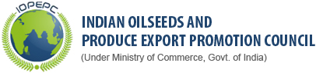
 | Indian Oilseed and Produce Export Promotion Council (IOPEPC) is concerned with the promotion of various Oilseeds and Oils. | 8/79, Bajaj Bhavan, Nariman Point, Mumbai - 400021. Maharashtra, | Ph No (91 - 22) 2202 3225 / 9295 | Email: info@iopepc.org | http://www.iopepc.org/
 | IOPEPC Circular |  |  |  | http://www.iopepc.org/misc/circ.htm
 | Registration with GACC for Exports of Oilseeds and Oils to China |  |  |  | http://www.iopepc.org/misc/igoc2021/GACC.HTM
 | Major Oil seeds |  |  |  | http://www.iopepc.org/products-major-oilseeds.php
 | Edible Oil |  |  |  | http://www.iopepc.org/products-edible-oils.php
 | HS Codes under the Purview of IOPEPC |  |  |  | http://www.iopepc.org/product-hscode.php
 | Export Statistics |  |  |  | http://www.iopepc.org/statistics-exports.php

