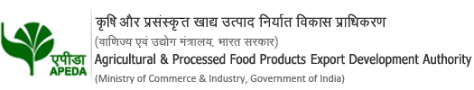
 | Agricultural and Processed Food Products Export Development Authority (APEDA) |  |  |  | https://apeda.gov.in/apedawebsite/about_apeda/About_apeda.htm
 | Trade Notice |  |  |  | https://apeda.gov.in/apedawebsite/miscellaneous/tender_notice.htm
 | Financial Assistance Schemes |  |  |  | https://apeda.gov.in/apedawebsite/trade_promotion/Financial_Assistance_Schemes.htm
 | Other Govt. Department Schemes- Ministry of Food Processing Industry
 | Mega Food Park – |  |  |  | https://www.mofpi.gov.in/Schemes/mega-food-parks
 | Pradhan Mantri Kisan SAMPADA Yojana |  |  |  | https://www.mofpi.gov.in/Schemes/pradhan-mantri-kisan-sampada-yojana
 | Production Linked Incentive Scheme for Food Processing Industry (PLISFPI) |  |  |  | https://www.mofpi.gov.in/PLISFPI/central-sector-scheme-production-linked-incentive-scheme-food-processing-industry-plisfpi
 | International Trade Fairs |  |  |  | https://apeda.gov.in/apedawebsite/trade_promotion/International_trade_event_2020_21.htm
 | Membership registration |  |  |  | https://itrack.apeda.gov.in/onlineregistration/apedaonline.aspx
 | INDIA EXPORTS STATISTICS |  |  |  | https://agriexchange.apeda.gov.in/indexp/reportlist.aspx

